
SOUTHLAND HERB SOCIETY
HERBAL HARVEST

June 2026

EDITORIAL

Dear Herbies
Amazing that we are still getting some sunshine each day!
Well my nerves have settled again this morning, after being at the Steel vs Tactix game at the stadium yesterday. What a game and what a privilege to be able to be there. Makes me so proud to be a Southlander!!
Lots to read from our Garlic meeting. I always get inspired by these people who go with a passion and reach out to do something different. Amy and Simon have certainly done this and are also looking at new opportunities as well. I also enjoyed Annette’s quiz which was lots of fun.
We are looking forward to the Bavarian Night on 25 July at 6pm. The band of 9 sounds amazing, as does the food, as always.
Enjoy this read while you keep warm and dry.
Till next time. Rose
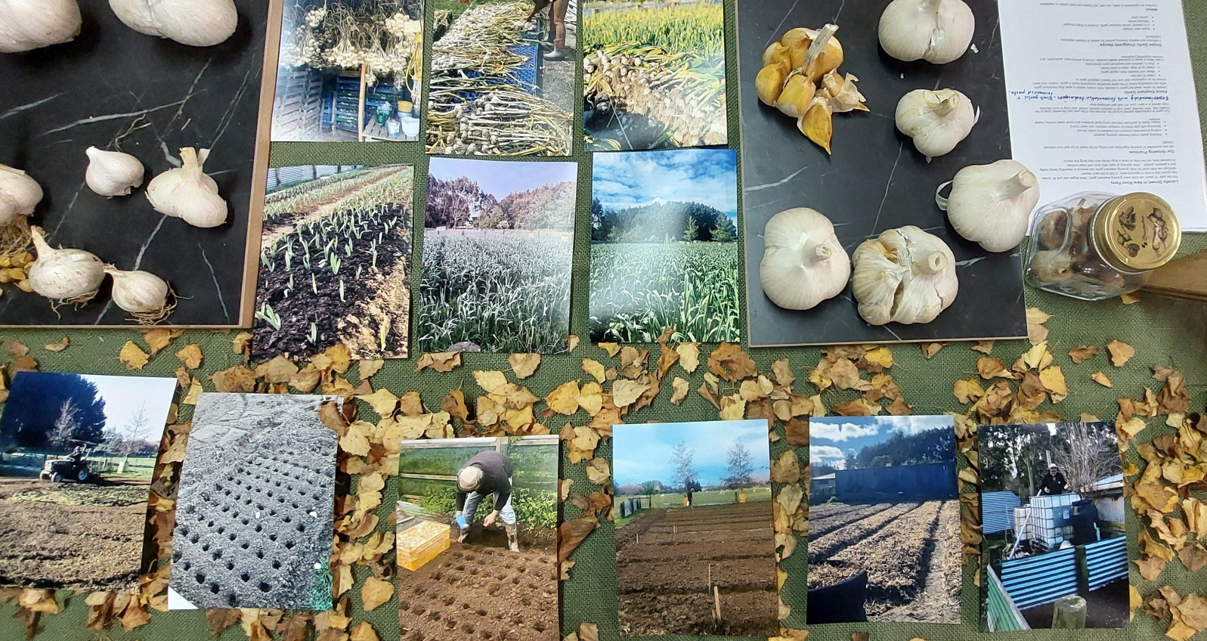
The AGM will now be held in August. More information regarding this and subscription information will be in the next newsletter.
2026 PROFILES
July - Joy Spriggs.
August - Ann Taylor.
September - Colleen Balneaves.
October - Glenda Wells.
November - Renee Jackman.

Fragrant Garden Groups
Anyone is welcome to potter and take out weeds, remove dead heads at anytime.
Garden inside the gate | Jane, Judith T., Annette, Lynette.
Rose garden with lavender | Lynley, Christine, Jocelyn, Linda R., Norma
Thyme garden | Pauline L, Alice, Judith W
Long garden in front of building | Sue J, Sue Mc, Julianne, Jenne, Denise, Noeline, Rose.
Round garden | Jackie, Judy C, Jill W
Camelia garden | Carey, Jan, Adair
MEETING GROUPS 2026
Please arrange to swap with another member if you are unavailable for the team you are in.

JULY – Jocelyn/Marianne, Lynette, Carey, Renee, Judith, Chrissie S.

AUGUST – Gillian/Jill, Joy, Sue McK, Joanne, Denise, Anna, Lois

SEPTEMBER – Sue/Pam, Karen S, Helen, Jackie, Marilyn Susie

OCTOBER – Rose, Kelly, Deidre, Ainslee, Karen, Jill W, Penny

NOVEMBER – Chris, Judith 0T, Adair, Lorraine, Rosie, Glenda W, Anne

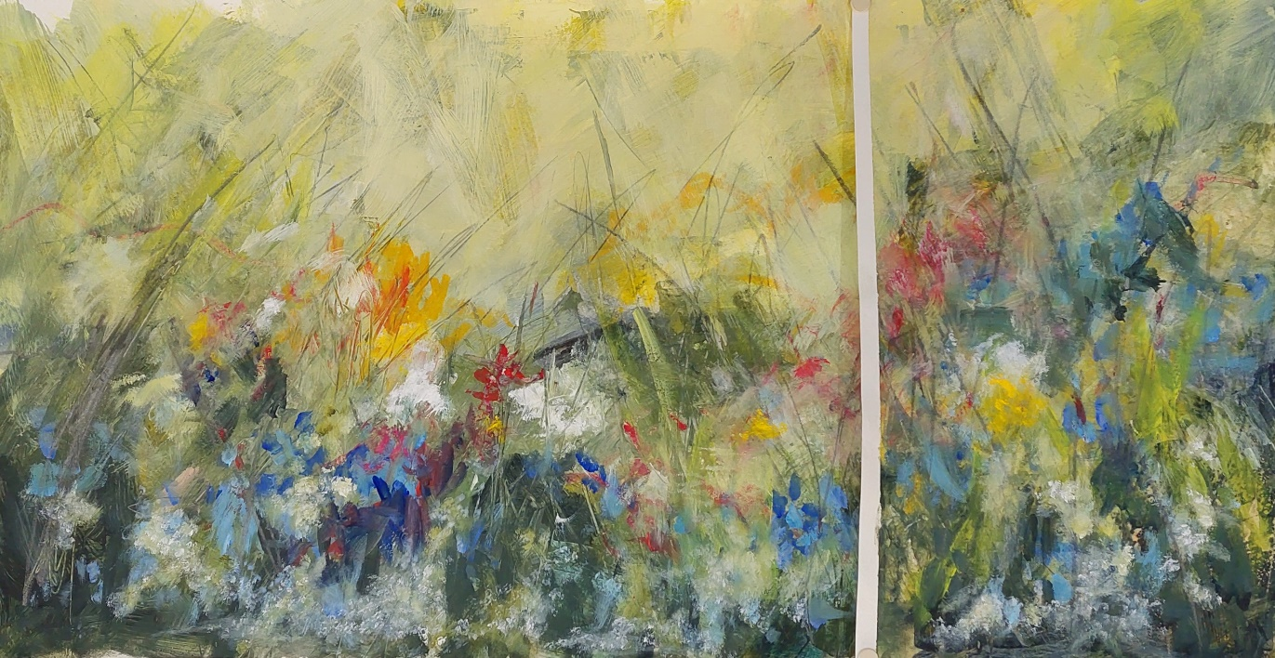
Where the Wild Garlic Grow.
PRESIDENT’S REPORT
June 2026
Good Day Everyone.

Winter is suddenly upon us, today being 8th June, after those lovely sunny days enabling us to enjoy outdoors. I love the early mornings just after the sun has risen, often singeing the horizon with all colours scarlet and red, creating long mysterious shadows amongst the almost bare trees and shrubs: the grass dancing with diamond shapes of dew. Love the patterns of tree branches against the backdrop of sky. I do hope you can enjoy them too.

First, Herb Society business. At the end of this financial year, realistically the end of June, but at our AGM in August, 4 of our committee members wish to retire. I am therefore asking if anyone would be interested in taking their place. It only takes a small amount out of your busy lives to help make sure The Society runs smoothly for the continued pleasure of all members. Please contact myself or Pam Wilson, our secretary, for more information. Many thanks.

My husband has found a couple of very useful tips amongst his Facebook friends (as if he does not have anything else to do!!): ivy soap and beeswax material bags for storing sourdough preventing it from going too hard quickly.
Ivy leaves contain saponins, a soap substance, which when older leaves are boiled for about 30 minutes in water, then left to stand overnight to allow the saponins to be absorbed and drained squeezing the leaves to remove as much as possible, results as a soapy liquid which our ancestors used for cleaning anything. It is very safe and does not contain any chemicals, but thus only last about a week in the fridge before decomposing.

I am sourcing beeswax material that is not too expensive and large enough for a loaf of bread. I see that our friend Brit, the sourdough baker in Dee St, is looking for new premises, as her present landlord wants the whole building to be used, not just at street level. I hope she finds somewhere central and easily accessible. Her biscuits are to die for!!

Our future meetings: This month is our Bavarian Mid Winter Dinner. All planned, details for those who have let Pam know you will attend, are below.
July is our annual workshop, again details follow.
August will include our AGM, which we will ensure is as short as possible as we have asked Kay Furness to come to tell us about succulents. Fay worked for many years for Parks and Reserves especially in The Hot House in Queens Park. If you have any information to contribute about successes and failures, or any lively tales about growing succulents, please do not be afraid to tell us at the meeting. Global Delights from Fay and perhaps Gillian.

The Road Trip, Saturday 26th September, is still planned to go ahead, details of venues later and the October meeting will be a surprise!!!!!

In November we will visit two gardens in Otatara, with supper at The Cabbage Tree.

Anderson House is holding a Christmas Display Winter Wonderland, Matariki Weekend, 17th to 19th July. It will be quite spectacular, put together over 10 days by Annie and Greg of Argyll Cottage Garden: we were there last November.

Stay warm, take care and I look forward to welcoming you to at least one of the above meetings.

Take care. Jane

MAY MEETING REPORT
GARLIC.

Report on our meeting Thursday 28th May 2026.
I hope you all enjoyed our meeting tonight. Many people have told me they learnt something new tonight so, job done. A big thank you to Jessie, Judy, Avis, Lyn and Jenne for all their hard work.
We started off with Lyn and Garlic in Folk Law and then onto our guest speakers Amy Nicholl and Simon Wilson who told us all about Elephant Garlic. For those who were there I am sure you could see the passion this brother and sister team brought to their talk.
Then Avis talked about pickled and dried garlic and she has inspired me to have a go at pickling garlic.
Well done to those who answered the quick quiz questions. All I did was pop garlic cloves in a pot (pointy side up) and was very surprised and delighted when all of them took. I hope the recipients are able to continue growing them in their gardens.
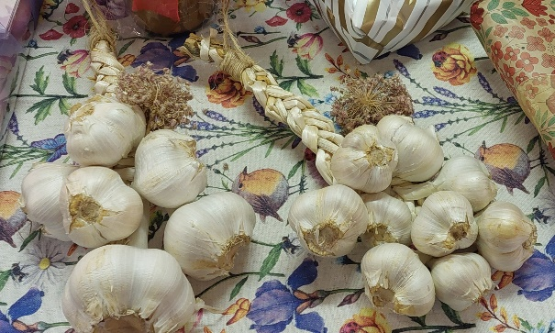
After the quiz Jessie gave us her book review as usual in her entertaining and informative style.
Raffles and supper followed.
I hope all the write ups in the newsletter prove to be a future reference point for everything we learned tonight. Happy reading. Annette.

ELEPHANT GARLIC LOCALLY GROWN IN NEW RIVER FERRY.
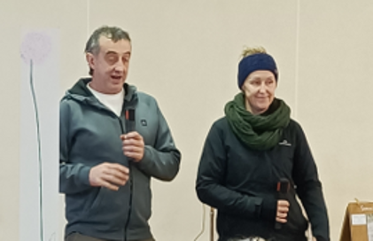
Report from Amy and Simon on their talk to us this evening.
For the past 15 years we have been growing elephant garlic. What began with just 80 cloves has grown into a crop of approximately 15,000 bulbs each season. Although we both work full time, growing elephant garlic has become a rewarding family hobby and a passion project. Often planting at night after work with head torches. At harvest time we are lucky to have a large family who help bring the crop in.

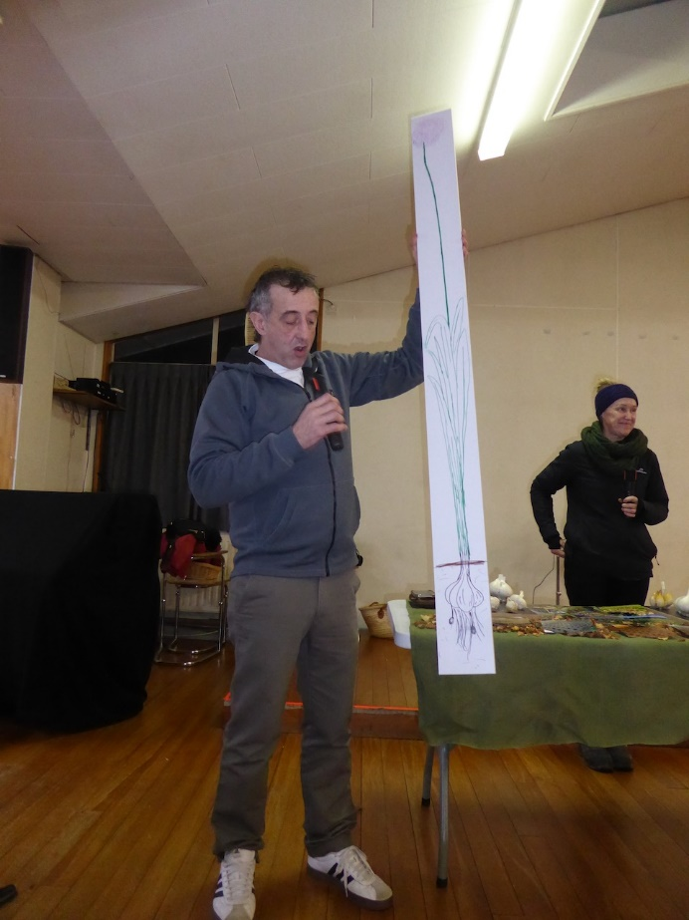
OUR GROWING PRACTICES.
This photo of Simon shows just how tall the plant becomes when ready to harvest.
We are committed to growing organically and caring for the health of our soil. Our methods include:
- Planting green crops between growing seasons.
- Adding homemade compost and seaweed to enrich the soil.
- Mulching with pea straw for moisture retention and weed control.
- Heavy feeds at particular intervals using liquid fertilizers and home-made comfrey- based fertilizer.
Our garlic is traditionally planted around the shortest day of the year and harvested close to the longest day. After harvest each bulb is carefully cleaned, sorted, and hung to cure naturally. Then it is stored in a dark, cool, dry and well- ventilated area.
Lately we have been experimenting with fermentation techniques, looking at black garlic and fermented paste.
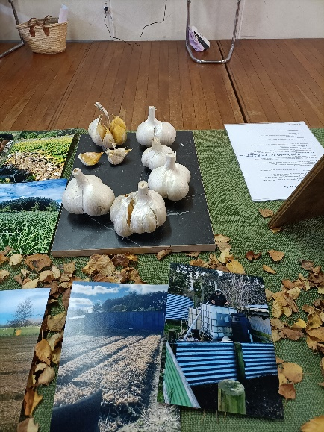
ABOUT ELEPHANT GARLIC.
Despite its name Elephant Garlic is actually more closely related to leeks than traditional garlic, while still containing many of the same beneficial compounds found in garlic, onions and leeks. Known for its impressive size and mild flavour, elephant garlic is:
- Easier to eat raw.
- Milder and sweeter than regular garlic.
- Made up of large, easy-to-peel cloves.
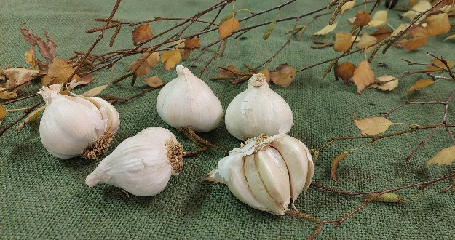
- Rich in vitamins and beneficial plant compounds.
It also offers a range of potential health benefits, including antimicrobial, antioxidant, and immune-supporting properties.

Wow such an interesting and informative talk tonight. Below are some extra points I managed to jot down which aren’t included above. I asked Amy and Simon to check them over for accuracy as with so much information coming at you it is easy to make a mistake and I figured the bullet point system was the best way to present it.
- Weeds are a big problem but not so big when you have a flame thrower to burn them off! Pea straw has proved very successful in containing them.
- Started out with a pick axe and shovel and recently progressed to a new plough.
- The green crops mentioned above, planted between growing seasons include mustard, lupin and barley. Grown to just below knee height and then ploughed back into the ground. Then the soil is treated to some horse manure, comfrey fertilizer and seaweed.
- Experimenting with planting with the full moon.
- Elephant garlic is a heavy feeder.
- Sells the produce at plant stores and farmers markets.
- When the garlic flowers appear snap them off otherwise all the growing energy goes into them and not the bulbs. Flowers appear in the last couple of months of the growing cycle.
- Sometimes you only get a wee onion. Maybe because it isn’t cold enough as elephant garlic likes the cold frost and snow.
- The first year of planting you get the onion as well and then the second year you get the bulb.
- Sometimes you just get a wee bulb and inside that you get a garlic pearl which you can eat.
- Amy and Simon say they haven’t had a problem with pests or diseases.
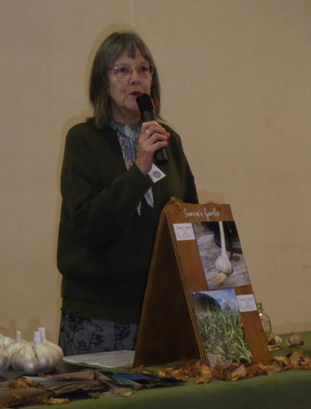
- Elephant garlic has some likes and dislikes. Doesn’t like wet feet especially at the end of the growing season. Likes a good air flow so hang it up where there is a good breeze. Hates sunlight.
Amy and Simon are branching out into Black Boy peaches and have 150 trees. They yielded a crop of 800 peaches off two trees so if that’s an indicator I think they are going to do very well with peaches also.
Thank you both for taking the time to come and speak to us. We learnt heaps!
Annette.

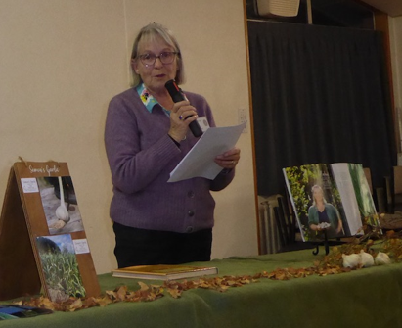
GARLIC – ALLIUM SATIVUM
Garlic is a species of bulbous flowering plants in the genus Allium. Its close relatives include the onion, shallot, leek and chives.
Allium sativum (meaning “cultivated”) is the culinary variety. Wild garlic or Ramsons (Allium ursinum, from Latin ursus meaning ‘bear’, as they like to eat the bulbs after hibernation) grows widely throughout woodlands in Europe.
Allium triquestrum is the common onion weed, with its three-cornered leaf.
Elephant garlic (Allium ampeloprasum) is a variety of wild leek, not a true garlic.
Garlic is native to Central Asia, northeastern Iran and the foothills of the Himalayas. It has naturalized in many other parts of the world, including Mediterranean Europe and China. There are two subspecies and hundreds of varieties of garlic.
Garlic was known for traditional medicine in many ancient civilizations dating back thousands of years, including the Babylonians, Egyptians, Jews, Greeks, Romans and Chinese, and to this day remains significant in many cuisines and folk treatments, especially across the Mediterranean and Asia.
In his book Natural History, Pliny the Roman naturalist and author (C1st A.D) gave a list of conditions in which garlic was considered beneficial. The Greek physician Galen, writing in the second century A.D, eulogized garlic as the "rustic's theriac" or cure-all.
It was used as a palliative for heatstroke in field labour around the12th century, and as an application for smallpox during the 17th century.
The herbalist Nicholas Culpeper, who worked in 17th C London, was a radical in his time. He angered his fellow physicians by condemning their greed, and use of harmful practices such as toxic remedies and bloodletting. He attempted to make medical treatments more accessible to the populace by using herbal remedies including garlic. He used garlic for curing rabies and snakebites, killing intestinal worms, fixing spots and blemishes, swellings and ulcers, and for regulating women’s courses.

MYTHS AND LEGENDS
Revered and reviled for its strong taste and aroma, garlic has been used for thousands of years for its alleged magical and therapeutic properties. Stories have been passed down throughout the centuries and cultures, especially in Central and Eastern European countries.
Garlic is associated with Mars, the Roman god of war and the primordial element of fire, and has a rich history and symbolism in beliefs, superstitions, myths, and legends worldwide.
In Europe, many cultures have used garlic for protection and rituals of white magic.
White magic is traditionally referred to as the use of supernatural powers or magic for selfless purposes. Practitioners of white magic have been given titles such as wise men or women (such as Wiccans), healers, white witches or wizards.
Many of these people claim to have knowledge passed down through hereditary lines. White magic is practiced through healing, blessing, charms, incantations, prayers and songs. It is the benevolent counterpart of malicious black magic.
WEREWOLVES AND VAMPIRES
Central European folk beliefs considered garlic a powerful ward against demons, werewolves and vampires. To ward off vampires and evil spirits and demons, witches and sorcerers, garlic could be worn, hung in windows, or rubbed on chimneys and keyholes.
In Romania, garlic braids are often hung in homes to ward off evil spirits and vampires, and to protect against illness. It is believed that if a vampire touches garlic, the creature will be weakened or destroyed.
In Siberia, the souls of women who died during childbirth and came back to torment the living are said to be recognizable by the garlic smell they spread.
In the old customs of the French Var region, during the celebration of Saint John’s Day, garlic was fried in the fires that were lit in the streets. The locals believed that the intense smell of fried garlic would drive away evil spirits and protect their dwellings.
In Mexico, the plant had to be received as a gift to effectively drive away vampires.
Roman legionnaires carried garlic as a means of protection during battles. Due to its prevalence in the soldiers’ diet, the plant became a symbol of military life.
Various garlic superstitions can also be found in old Islamic legends. One such myth talks about garlic that sprang up under the Devil’s left foot when he was cast away from the Garden of Eden.
In a Buddhist medicine treatise dating from the 5th century, there is a legend that the herb was born from the blood of a demon.
During some celebrations in ancient Greece, women ate garlic, as it was believed that the plant facilitated the maintenance of the chastity imposed during the festivities. The ancient Greeks placed garlic on the piles of stones at crossroads, as a supper for Hecate, the goddess of magic, spells, the moon, the night, and crossroads.
From the Mediterranean basin to India, the most persistent belief is that the herb wards off the evil eye. For this reason, wreaths of garlic heads tied with red wool are often seen in Greece, India, and Italy. In ancient Greece, merely uttering the word “garlic” or “σκόρδο” (pronounced “Skordo”) was believed to protect one from the evil eye.
In China, the condiment is associated with luck and fertility and is often given as a gift to young parents to encourage them to have many children.
Koreans of the past ate large quantities of this condiment before embarking on mountainous routes, firmly convinced that the smell repelled tigers.
Archaeologists have found garlic bulbs encased in clay alongside the bodies of the departed in Egyptian tombs, including that of King Tutankhamun c.1325BC. Whether they were meant to placate the gods’ wrath or represented coins for the afterlife is still being determined.
Both garlic and onions played a significant role in Egyptian processions relating to sacred oaths. The ancient Egyptians revered these two plants for their magical and healing properties. Their divinity was so powerful that the Egyptians refrained from using them in their cuisine.

GARLIC’S ASSOCIATION WITH VAMPIRES
The term vampire first appeared as upir in an old note written by a Russian Orthodox priest circa 1047, where the “evil upir” was mentioned. It is thought that the word upir originates in the ancient Tatar language meaning “witchcraft” or “magic.”
Another reference dating back to the 11th century relates to Saint Gregory, who spoke of a pagan cult that worshiped specific upirs.
It is possible that the myth of garlic being able to repel creatures from the dark arose from the fact that excessive consumption significantly affects the smell of one’s breath!
Bram Stoker’s 1897 novel “Dracula” also contributed to the spread of the belief that garlic, along with the cross and holy water, represents effective weapons against vampires. Some historians suggest the legend’s origins of vampire “sightings” could potentially be associated to porphyria, a rare blood disease that exhibits symptoms such as a pale complexion and elongated teeth due to shrinking gums. Garlic and sunlight are said to make the symptoms worse so people with the disease often avoid both, only adding to the legend.

Through the ages plaited bulbs were commonly hung in the home as a powerful talisman against demonic forces, protecting all who were surrounded by their fragrant aroma. People would rub cloves of garlic on the chimney or windowsills or grow garlic near doorways. What was once thought to be protection from vampires has credence now as a useful rodent repellent.
Mice and rats shy away from the strong scent of garlic, thus ridding the home from potential disease carriers and overall, creating a healthier living environment.

During the time when most of these legends came about, sickness was often seen as the work of evil. It was thought that a vampire’s bite would cause a “blood sickness” resulting in hallucinations, a high fever, and a general wasting or malaise. With our modern knowledge and technology, those same symptoms can also describe many infections, such as tuberculosis or the flu.

Garlic is a natural immune booster, and unbeknownst at the time, could, in fact, help in healing those illnesses. With more advanced scientific knowledge, we know that the bulbs contain high levels of vitamin C and vitamin B6, as well as manganese.

Garlic is widely advertised to be a natural supplement for heart health. The cloves, rich in a sulphur compound called allicin, provide antioxidants that can help our bodies block free radicals and the harm they may cause.
All in all, garlic is a powerful medicinal plant, and who knows, may also repel those evil forces!
As a side bar, I recently attended an art course in Cornwall. During the day we would go ‘plein air’ sketching. I was fascinated by the diversity of flora in the hedgerows, including copious quantities of wild garlic Allium ursinum and onion weed Allium triquetrum.
It was also ‘bluebell time’ in springtime Cornwall, and, like Jessie in Wales, I delighted in the swathes of bluebells and wild garlic drifting along coastal pathways and cliffs, so different to our flora in New Zealand.
References –
Nicholas Culpeper – Culpeper’s Complete Herbal and English Physician – edition Harvey Sales 1981
https://en.wikipedia.org/wiki/white_magic
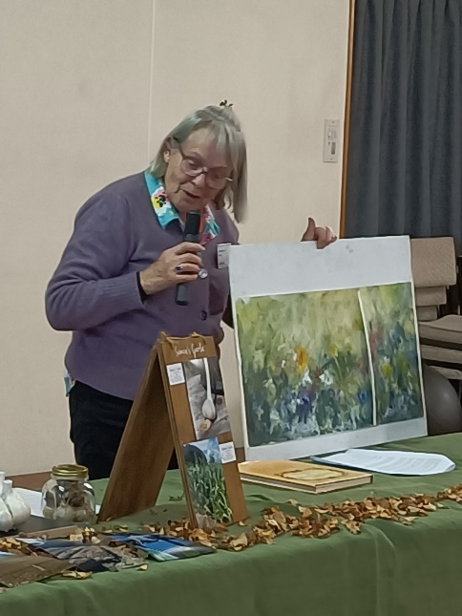
https://ancient-theory.com/garlic-superstitions-myths/
www.countryfile.com
www.WoodlandTrust.org.uk
www.rhs.org.uk
BOOK REPORT
The Magic of Herbs
by Jane Newdick

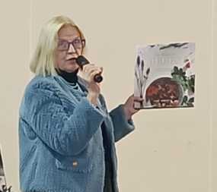
I just loved reading the article on garlic in this most informative book. The illustrations are wonderful and there are great recipes which include all types of herbs.
The author Jane Newdick was a well-known magazine writer for three years before she decided to write freelance from her home in the beautiful countryside of Sussex. She now spends all her time working in and enjoying her garden, as well as being the author of books on herbs and flowers.
Garlic is of course a hardy perennial belonging to the onion family. It is a plant which has been used since ancient times throughout the world not only to add to food, but as a medicine or even as a magical charm to ward off evil spirits. In medieval times in Britain, it grew extensively for use in the kitchen and was even believed to keep away the plague.
In those days it was known as ‘gar leek’ because the cloves were spear shaped and gar was an old English word for a spear.
Garlic is as popular today as ever it was in the past and is used to add flavour and a cosmopolitan touch to food. It is still sold by pharmacies too, as many people still believe it has benefits for health.
Of course, it is especially popular in Mediterranean countries where they have some of the healthiest diets and best tasting food, which I might say goes down especially well with a nice glass of red wine.
Garlic is an attractive plant with beautiful white flowers but of course the edible part is the bulb growing beneath the ground. It is easy to cultivate but does require a long growing season with plenty of sun and light and nice moist soil, which I suppose is why it does so well in countries around the Mediterranean. Another reason it was prized in the past was because it is easy to store for long periods, up to a year if kept in a cool airy place.
The book gives three great recipes which include garlic, all of which sound delicious.
They are Chilli and Garlic spiced vinegar, Pot roasted chicken with garlic and Garlic bread.
What I like about them is they are all so easy to prepare.
I always put garlic in my pasta dishes and in my Irish Stew to add a little bit of extra flavour.
Nowadays garlic is often listed as superfood, meaning that it has benefits for health as well as for diet.
It is claimed to help with lowering cholesterol, helping type 2 diabetes, digestive health, heart health, weight control and even cancer.
I don’t know how much truth is in those claims, but even if it is only partly true, garlic is indeed an amazing herb.
The benefits of garlic for food, or for health are often talked about, but what is less often mentioned is what a beautiful plant it can be. So let me take you on a journey to Anglesey in North Wales to the Penrhos Estate on the very tip of that island. There I used to love to walk amongst fields and woods covered in masses of wild garlic interspersed with bluebells. As I walked through my feet would brush against, or I suppose sometimes crush the wild garlic sending the most beautiful smell to fill the air. We had a walled garden behind our house, and I used to sit there on Shackleton’s rest looking out over the woods filled with a mmix of trees, wild garlic and bluebells. It was heaven on earth and perhaps the beautiful memory of any place I have in my mind.
The funny thing is we lived here for three years, and I never ever tried to harvest the garlic. It just looked too lovely to disturb.
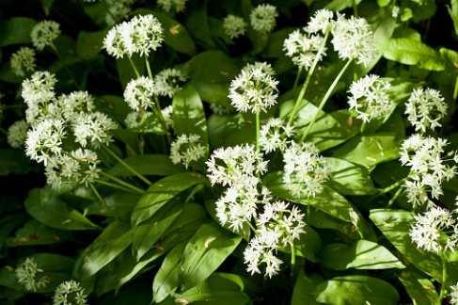
In Britain, garlic is also known as ramsons and it grows wild in British woodlands in the warmer parts of the country, forming carpets of white flowers especially in shaded areas. It has always been sought after y foragers who use the upper part of the plant to add flavour rather than the bulb in soups and salad.

I never thought that nearly thirty years later I would be in New Zealand writing about wild garlic of the Penrhos Estate and doing this has brought back lovely memories.
Garlic also fights black spot on your roses.
Enjoy your garlic gardening and cooking!

SIMPLE GARLIC VINAIGRETTE RECIPE.
A delicious and healthy dressing is perfect for salads or roasted vegetables.
Ingredients:
Apple cider vinegar.
2-3 medium cloves elephant garlic crushed or finely chopped.
Manuka honey.
Lemon juice.

Combine all ingredients to taste, mix well, and drizzle over fresh salads or vegetables.

SOME WAYS TO PRESERVE GARLIC
- Firstly, harvest your garlic and cure it for a few of weeks until the stem is completely dried out. Trim off the tops and roots and store in the dark in a wire basket or paper bags with the aim of air circulation. Your garlic should store well for months.

- The peeled cloves can be ground up in a food processor and smoothed out in a thin layer in a plastic bag. Remove the air and seal the bag and pat flat. Take a chopstick and make indentations about one inch lengthwise and across to form a grid pattern. Freeze the bag flat and simply break off one of the squares when required for cooking.

- Dehydrate a whole lot of cloves (with skin on) until perfectly dry. Place them in a coffee grinder and make into beautiful garlic powder. Evidently the skins are very nutritious, so don’t waste them. I recommend this way as there is no sticky fingers from the peeling process! I did this with all my little bulbs.

- If you have honey available, peeled garlic cloves can be preserved by placing in a jar, covering with honey, before flipping the jar upside down. This allows the lactic acid bacteria to consume the sugars in the honey which will ferment and preserve the garlic.

- If you have a food vacuum packer, you can vacuum pack bulbs of garlic and toss them into the dehydrator for 2-4 weeks (about 40 days) (at 60-90 degrees C) to slowly cook. This Korean method creates black garlic to use in a sauce or to spread on bread or crackers and has a mild, sweet flavour. Can be processed in a rice cooker or slow cooker also.

MESSAGE BOARD

JULY WINTER WORKSHOP
Saturday, 25 July – 10.00 am start to mid afternoon.
WRITE, COLLAGE, DOODLE and COLOUR with Lynley Tuckey
Arthur Cushen Blind and Low Vision Centre

Bring your own lunch and snacks and money for raffle.
MATERIALS TO BRING FOR THE DAY.
A4 or A5 Visual Diary - unlined and water-resistant— available at any stationery shop, Art Supplies, Warehouse etc.
A water proof fine line black pen—available at above shops.
An inexpensive paint brush that is not soft or pointy.
Any pencil , an eraser and pencil sharpener.
Scissors.
Coloured pencils.
A rag and some newspaper.
Any queries email me - lynley.tuckey@gmail.com
Bring you own lunch and snacks.
Tea and coffee provided.
Any queries or concerns about the day, please email me. lynley.tuckey@gmail.com

BAVARIAN MID WINTER EVENING
June 25th 2026 @ 6.00pm

This year’s Mid-Winter Dinner has a strictly Bavarian theme. Bavaria being the south eastern state of Germany, set mostly in The Alps, being well known for its fairy tale castles.

The Herb Society committee has planned a great evening of music (provided by The Rhythm and Brass Band – they were playing the Saturday at Anderson House 100 years,) local dishes and drinks.

This year the menu will be less varied, still delicious, we ask those attending to supply a plate of food to feed 10 people, according to the month in which you helped at a meeting.

You will need to bring along the usual items to the night, ie main and dessert plate, cutlery, drinking glass – a stein mug if you have one – relevant Bavarian attire and any souvenirs, photos, memorabilia of the area. Remember this is strictly a Bavarian Evening, it does not include the rest of Germany!!!! You will be given a welcome drink when you arrive, otherwise please bring your alcohol preference. Non-alcoholic juice will be available.

The band will entice us to join in with their songs and dance music – v loud!!!!

If you are preparing a dish that can incorporate herbs, below are some suggestions.

KEY BAVARIAN WILD HERBS & PLANTS

Bärlauch (Wild Garlic): Pungent herb found in spring, used in pesto and soups.
Löwenzahn (Dandelion): Young leaves are used in salads, often called "lion's tooth".
Stinging Nettle (Brennnessel): Nutrient-rich herb used for tea, soups, or as spinach.
Giersch (Ground Elder): A common aromatic wild vegetable.
Spitzwegerich (Ribwort Plantain): Used for soothing coughs and skin irritations.
Masterwort (Meisterwurz): A classic Alpine herb used in traditional medicine.
Blutwurz (Tormentil): A potent root used to make a bitter red digestive liqueur. [1, 2, 3, 4, 5]
Common Culinary Herbs in Bavarian Gardens [1]

Chives (Schnittlauch): Often used in "Schnittlauchbrot" (bread with chives).
Marjoram (Majoran): Key in local sausage and potato dishes.
Parsley (Petersilie): Essential for garnishing and soups.
Thyme (Thymian): Common in meat and fish seasoning. [1, 2, 3, 4, 5]
Regional Specialties

Kreidelsuppe: A traditional Easter herb soup in Upper Bavaria.
Bayerischer Bärwurz: A, a clear spirit produced from the roots of Meum athamanticum.
Ettaler Klosterlikör: A medicinal liqueur from a Benedictine Abbey in the Bavarian Alps. [1, 2]

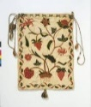

EMBROIDERY GROUP
Wednesday 24 th June at:
Lorraine Ker’s, 97 Joseph St, Ingill

This mortar and pestel was left behind after our meeting, on one of the display shelves. Currently having a holiday with Annette.

We have received a request from HFNZ asking if we would like to put together an article about common flax. Adair is happy to help, and we ask if there are any members who would like to join a 'writing group' to do this. Please contact Adair: genge@xtra.co.nz or Jane: hobbiton@kinect.co.nz if you can assist with this project.

COMMITTEE INFORMATON:

President: Jane Jones Ph: 0272459656 Email: hobbiton@kinect.co.nz
Past President: Julianne Watson Ph:03 2358020 Email: julianne.watson50@gmail.com
Vice Presidents: Linda Ryder Ph: 0274774750 Email: lindayoga4u@gmail.com
Marianne Wilson Ph: 0275875994 Email: melias@hotmail.co.nz
Secretary: Pam Wilson Ph: 0274147140 Email: pamves@gmail.com
Treasurer: Gillian Knarston, Ph: 0277276118 Email: gillianknarston@hotmail.com
Editor: Rose Buxton Ph: 02102387312 Email: roseannebuxton@gmail.com

If you would like to contact us, please email:
southlandherbsoc@gmail.com or pamves@gmail.com

The Southland Herb Society accepts no liability for any ill effects resulting in the use of information printed in this newsletter. Every effort has been made to ensure that all details are accurate. If in doubt, please consult a qualified herbal practitioner. Opinions and views expressed in any article are not necessarily those of the editor or the committee.

