Herb Federation of New Zealand
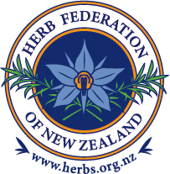

Herb Certificate Study Scholarship Application

There are two scholarships currently available—both allow the successful applicants to study the twelve modules of the Herb Federation of New Zealand Herb Certificate Course, at no financial cost.

- The HFNZ Scholarship is sponsored by the Herb Federation of New Zealand.

- The Heather Young Scholarship has been created in memory of the late Heather Young.

Name: ………………………………………………………………………………………………………………………..

Address: …………………………………………………………………………………………………………………….

…………………………………………………………………………………………………………………………………..

Email address: …………………………………………………………………………………………………………….

Phone/s: ……………………………………………………………………………………………………………………..

I am a current member of the HFNZ — Yes / No

Personal Essay:

As a separate attachment, please explain why you would be deserving of one of our scholarships; please include your plans for the future, in particular, relating to herbs and gardening.

- Show an appropriate level of interest in herbs.

- Where there is more than one applicant in any one year, preference will be given to: o Applicants who clearly state their goal for using herbs in their future life.
o Applicants who show a history of successful study, including (but not necessary) having started the Certificate course.

- I have read and agree to the terms and conditions of this scholarship.

Signed: ……………………………………………………………………

Date: ……………………………………………………………………….

Please send your application by the closing date of 15 October 2024 to:

The Secretariat

Herb Federation of New Zealand
PO Box 198
Inglewood 4347
New Zealand

Or email: herbfednz@gmail.com

